# Functional Specification

## Inventory Of Inventories

A.)

## Area Logging Service

B.)

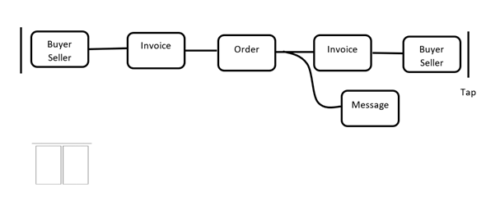

## Validation

### Buffer Validation, [IOI] Linear

Reference:

9780080560106